DIS-Paleo-EUR-FR-Paris Basin Middle Paleolithic-Mousterian type of debitage-Levallois method

flint blond white patina of the Paris Basin Middle Paleolithic. period of the Mousterian type of debitage Levallois method 100.000 TO 30.000 BC

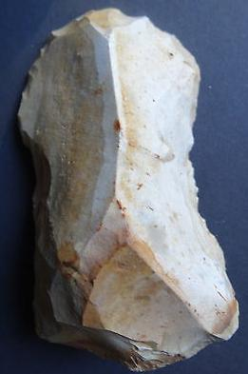

$40.00